Тема урока | School life  Комбинированный урок(закрепление)
Цели урока | Fix up the theme «School year».
Задачи | - Developing students’ knowledge on the topic.  - Developing critical thinking.  - Developing reading, grammar skills.  - Developing pair work (working in groups).
Лексика | School subjects, school objects, adjectives- large, kind, light, friendly.
Результаты обучения | Students can work in pairs, can find useful information, revise and repeat words. Students can use information in life.
Источники, оснащение и оборудование: | Smart board, presentation, tasks on the sheets of paper.
Этапы урока | Деятельность учителя | Деятельность учащихся
Организационный момент | Greetings. How are you? What’s the weather like today? What ‘s the day today? What’s the date today? What  season is it?  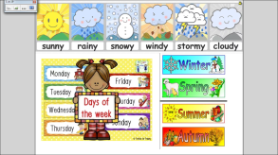 | Pupils greet tacher and answer to the questions. | 1
Определение  темы, цели и  задач урока  Актуализация знаний учащихся | Let’s look at the board. What can you see? It is a poem. Let’s complete it with the words. Let’s read and mime.  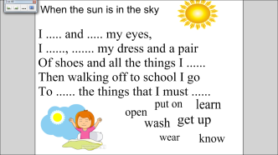  Let’s guess :what is the theme of our lesson today?  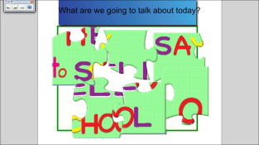  Let’s read what we will do at the lesson today.  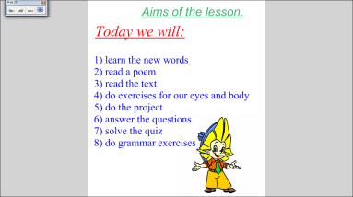  We’ll speak about school today. What do you see at school? What subjects do you have every day?  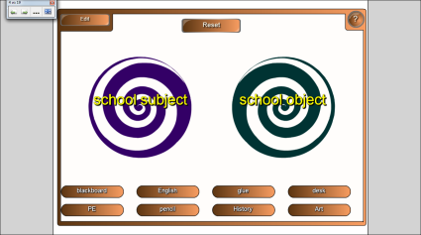  Are you good pupils? Do you know what can you do at school? What can’t you do at school?  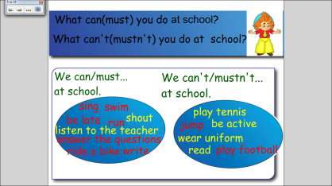 | Индивидуально-корпоративная работа (мозговой штурм).  Pupils complete the words in gaps, repeat after the teacher/ then read one by one.  Children guess the topic and  Children group the words according to the category.  The pupils choose and make up sentences to prove the they know how to be a good pupil. Then we’ll check. | 2  1  1  1  3
Основная часть урока | Pupils, how do you think If pupils in Africa have these rules too? Do African or Britain children go to school?  Today we’ll know about African children. Let’s read.  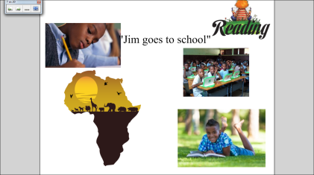  Let’s check how attentive you are/ Let’s put the sentences in the right order  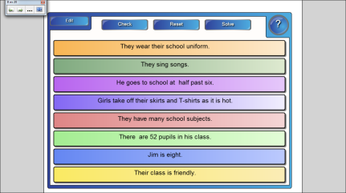  Right you. Thank you/ You read and your eyes are tired. Let’s do exercises for your eyes.  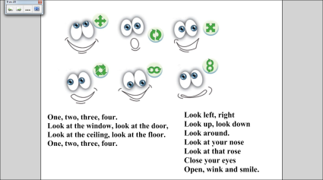  Look left, right  Look up, look down  Look around.  Look at your nose  Look at that rose  Close your eyes  Open, wink and smile.  Let’s continue our work. Your task to answer the questions to the text.  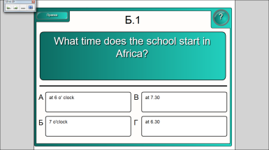  That;s a good job. And what about our school. Let’s compare.  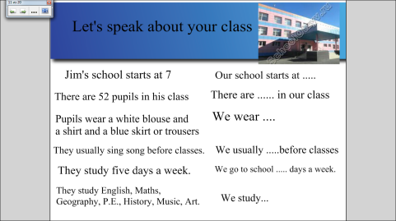  Thank you. You are very active today. Now you are tired, Let’s do exercises.  Do you like your school? But do you want to do it better? Let’s do a little project today about school of your dream.  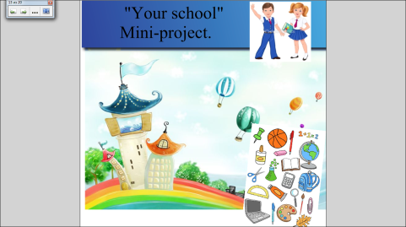  You’ve got such interesting ideas. Thank you.  You know so many words about school. School subjects…. Let’s check can you write them  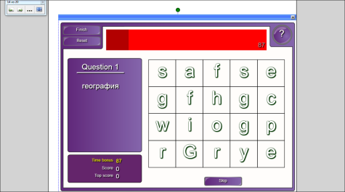  Can you help Neznaika, he doesn’t know what the sentences about. Let’s read these sentences.  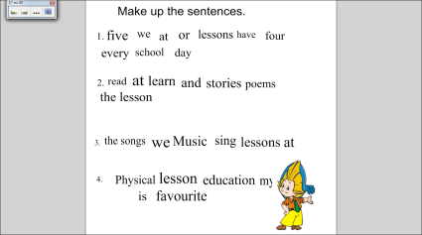  I’d like to ask you some questions now.(ball-game)  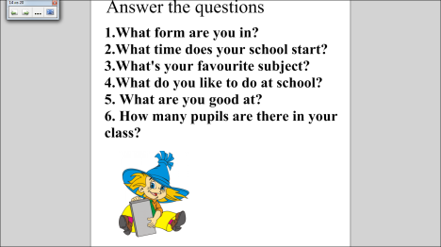 | Pupilы read the text.  Pupils think over the right order of the given sentences.  Children do exercises for eyes.  Children answer the questions bpressing the variant which they think is right.  The pupils compare our school and African one.  Doing exercises to have a rest.  Children think over the project. They have some prompts and using them the pupila make their little story about dream-school. They draw it.  The pupils find the school subjects on the board.  Children quess the order of the words and read their variant.  The pupils answer the questions catching the ball. | 5  1  1  2  3  1  8  2  2  2
Заключительная часть | You are very active today. I’ll put you excellent narks for today’s lesson. Your homework is to learn the words for dictation and to make the crossword.  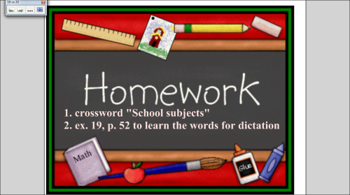  Do you like the lesson today?  What do you like most of all?  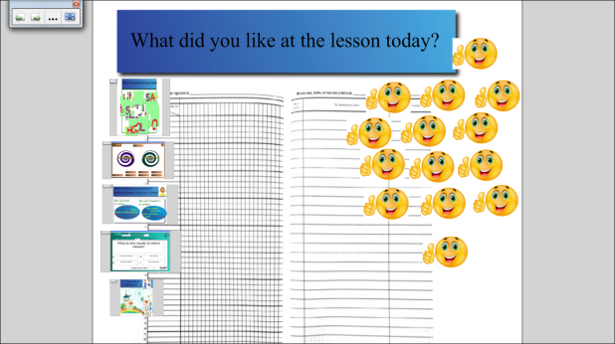  Are you happy?  Let’s sing the song.  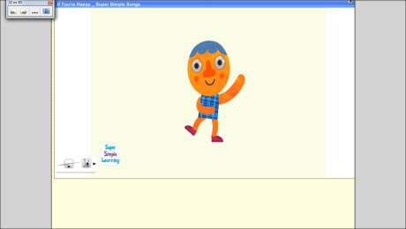  The lesson is over/ Thank you. Good bye. | Pupils put down their homework.  Pupils take the smile and put it to the part of the lesson they liked most of all.  Pupils do actions and sing the song. | 1  1  2

